Object Oriented Concepts
Object Oriented Concepts 1
Introduction 2
Class 2
Methods / Operations / Behaviors 2
Encapsulation 3
Abstraction 3
Abstract method will have only the definition in an Abstract class and the implementation will be done in the derived class. 3
Inheritance 4
Polymorphism 4
Design Patterns 5
Creational 5
Singleton 5
Builder Pattern 5
Structural Design pattern 8
Facade 8
Adapter Design Pattern 12
Behavioural Patterns 16
Strategy 16
Observer Pattern 19

Introduction

The use of a thing or object with its properties, actions.

An object is a real world example, this could be a car,ball, anything which has some thing to do with our real world usage.

In software the concept is used in the form of methods, properties and will be implemented in the technical representation.

What is an Object?

A thing from the real world, that we can store and process data.
Another name for an object is called Entity.

Fundamental Concepts

The fundamental concepts used in OOPS are followed below

Class
The Attributes technical we mention or declare it in a Class - Now with this we can understand A Class is a collection of properties/attributes to capture data.

So, based on the kind of Attribute we will have the DataType to be declared on an attribute.
We will provide the name to the class.

Example:
Class Student
{
Surname string {get;set;}
Name string {get;set;}
RollNo int {get;set;}
….…..
}
Once a Class is created this can be instantiated with an objects as needed.
It means An object is an instance of a class

Each object can be created with a keyword called new , this is also called as an constructor
Example:  Student student=new Student();  We can assign the values also to its Attributes | Example:  student.Surname=”MySurname”;  student.Name=”MyName”;  student.RollNo=1000;  Etc….

Methods / Operations / Behaviors
So in order to capture the data or do some functionality on the data we write some functions which are technically called as Methods/Operations/Behaviors.

Example:
StudentEnrollment();
StudentReport();

Encapsulation

Now from the above we have learned how to create some classes and methods.
When you are writing some methods we will be having some internal business functionality or calculations that we need to tell or make use of it to others ( I mean to say calculation or some business needs).
So, in this case we need to provide only those methods to the users which helps them to solve the problem and give the solution, the internally functionality is not required for them.

Example:
When you are buying a Pencil or a Pen you will pay the amount and mention the Brand of the required item, its not required for you to know how the ink is filled into the refill and how the refill is inserted into the pen right, with this we can understand the the Pen manufacturer is not providing you the details of how the make is done instead they are giving you the quality output of the pen.

In the same way when we do write operations or methods we have to hide the functionality and we just need to provide the name of the method to the end user who will use it.

This is called Encapsulation - hiding the complexity.

We will be using the keywords that can be used to control the visibility of attributes, methods of a class.

These keywords are called as Access Modifiers.
Based on the type of language you program it will vary
C# - public, private, protected, Internal
Java - public, private, protected, default

Example:
When sending an email we need to just pass the parameters to a SendEmail method
- Connecting to the smtp server
- Sending the email
This will be hidden to us -- the hidden part is framed as private in the SendEmail Class.

Abstraction
This hides the functionality and shows only the necessary part.

for example the internal mechanism of a machine is not required to an user, when the user just need to enjoy the functionality of the machine by starting it.

This will be implemented technically using the keyword abstract.

Abstract method will have only the definition in an Abstract class and the implementation will be done in the derived class.
Example:
Abstract class Machine{

Inheritance
This is some thing like the qualities, likes, dis-likes that we get from our fore-fathers. :-)

Technically, we wrap this as deriving a class methods,attributes from an another class.

Example:
Class Person{  Name string {get;set;}  Age int {get;set;}  Gender string {get;set;}  ….  } | Class Employee : Person  {  Designation string{get;set;}  Salary int {get;set;}  .….  Public int CalculateSal()  {  ……..  }  } | Class Manager: Employee  {  Salary int {get;set;}  .….  Public int CalculateSal()  {  ……..  }  }

We say here Person as a base class and Employee as a sub class and Manager as a subclass
Person / Employee can be also called super class and Manager as child class

Polymorphism
Poly means - many Morphism - forms or copies

We can say from the above inheritance if a class is inherited with its methods and attributes, the derived or sub class can mange the methods in its own form.

Example:
If we see Employee can be in many forms like , Software engineer, Manager, Sr.Software engineer and their individual salary calculation based on the remuneration when discussed in the HR round will be different.
So, when we inherit the base class in the manager class the salary pay will be calculated differently as with the Employee class Salary Method, here in the manager class the salary calculation method will be overrided if the role is as Manager.

Class Person{  Name string {get;set;}  Age int {get;set;}  Gender string {get;set;}  ….  } | Class Employee : Person  {  Designation string{get;set;}  Salary int {get;set;}  .….  Public virtual int CalculateSal()  {  ……..  }  } | Class Manager: Employee  {  Salary int {get;set;}  .….  Public override int CalculateSal()  {  ……..  }  }

The technical keywords - virtual and override.

Virtual - will be used in the parent class to morph the method in the derived classes.
Override - will be used to morph the parent method functionality in the derived class

Design Patterns

Creational

Singleton
This will be used to operate on the Logging, connection maintenance, basically this will be used when the operation is required in a multiple call.

This will improve performance and can be used in lazy loading.

Builder Pattern
This will be used to create objects of complex design, this is a kind of step by step approach in achieving the objective.
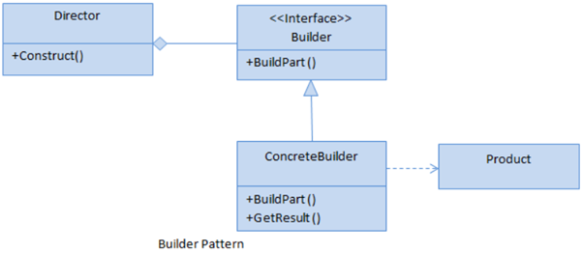
Builder
This is an interface which is used to define all the steps required to create a product.
ConcreteBuilder
This is a class which implements the Builder interface to create a complex product.
Product
This is a class which defines the parts of the complex object which are to be generated by the Builder Pattern.
Director
This is a class that is used to construct an object using the Builder interface.
Interface
public interface IToyBuilder {
- void SetModel();
- void SetHead();
- void SetLimbs();
- void SetBody();
- void SetLegs();
- Toy GetToy();
- }

Product class
- public class Toy {
- public string Model {
- get;
- set;
- }
- public string Head {
- get;
- set;
- }
- public string Limbs {
- get;
- set;
- }
- public string Body {
- get;
- set;
- }
- public string Legs {
- get;
- set;
- }
- }

Toy A
- public class ToyABuilder: IToyBuilder {
- Toy toy = new Toy();
- public void SetModel() {
- toy.Model = "TOY A";
- }
- public void SetHead() {
- toy.Head = "1";
- }
- public void SetLimbs() {
- toy.Limbs = "4";
- }
- public void SetBody() {
- toy.Body = "Plastic";
- }
- public void SetLegs() {
- toy.Legs = "2";
- }
- public Toy GetToy() {
- return toy;
- }
- }

Toy B
- public class ToyBBuilder: IToyBuilder {
- Toy toy = new Toy();
- public void SetModel() {
- toy.Model = "TOY B";
- }
- public void SetHead() {
- toy.Head = "1";
- }
- public void SetLimbs() {
- toy.Limbs = "4";
- }
- public void SetBody() {
- toy.Body = "Steel";
- }
- public void SetLegs() {
- toy.Legs = "4";
- }
- public Toy GetToy() {
- return toy;
- }
- }

Director
- public class ToyCreator {
- private IToyBuilder _toyBuilder;
- public ToyCreator(IToyBuilder toyBuilder) {
- _toyBuilder = toyBuilder;
- }
- public void CreateToy() {
- _toyBuilder.SetModel();
- _toyBuilder.SetHead();
- _toyBuilder.SetLimbs();
- _toyBuilder.SetBody();
- _toyBuilder.SetLegs();
- }
- public Toy GetToy() {
- return _toyBuilder.GetToy();
- }
- }

Main program
- void Main() {
- Console.WriteLine("-------------------------------List Of Toys--------------------------------------------");
- var toyACreator = new ToyCreator(new ToyABuilder());
- toyACreator.CreateToy();
- toyACreator.GetToy().Dump();
- var toyBCreator = new ToyCreator(new ToyBBuilder());
- toyBCreator.CreateToy();
- toyBCreator.GetToy().Dump();
- }

Prototype design pattern

It specifies the kind of objects to create using a prototypical instance, and create new objects by copying this prototype.
Instead of creating an object from scratch every time, you can make copies of an original instance and modify it as required
It’s a unique among the other creational patterns as it doesn’t require a class but only an end object.

Shallow and Deep copy plays prominent role in copying the objects in this pattern.
MemberwiseClone method
Is a part of system.object and creates a shallow copy of the given object.
This copies the non static fields of the chosen object to new object.
In the process of copying, if a field is value type , a bit by bit copy of the field is performed.
If a field is reference type the reference is copied but the referenced object is not.

ICloneable Interface
Provides with a customized implementation that creates copy of an existing object.
Contains one member, the clone method, which is intended to provide support beyond memberwiseclone method.

Structural Design pattern

Facade
Facade is a structural design pattern that provides a simplified interface to a library, a framework, or any other complex set of classes.
If we try to understand this in simpler terms, then we can say that a room is a façade and just by looking at it from outside the door, one can not predict what is inside the room and how the room is structured from inside. Thus, Façade is a general term for simplifying the outward appearance of a complex or large system.
In software terms, Facade pattern hides the complexities of the systems and provides a simple interface to the clients.
This pattern involves one wrapper class which contains a set of methods available for the client. This pattern is particularly used when a system is very complex or difficult to understand and when the system has multiple subsystems.
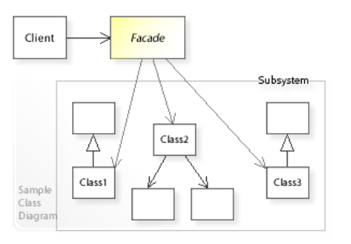
Here, we can see that the client is calling the Façade class which interacts with multiple subsystems making it easier for the client to interact with them.
However, it is possible that façade may provide limited functionality in comparison to working with the subsystem directly, but it should include all those features which are actually required by the client.
For example, When someone calls the restaurant, suppose, for ordering pizza or some other food, then the operator on behalf of the restaurant gives the voice interface which is actually the façade for their customers.
Customers place their orders just by talking to the operator and they don’t need to bother about how they will prepare the pizza, what all operations will they perform, on what temperature they will cook, etc.
Interface
- public interface IBread {
- void GetGarlicBread();
- void GetCheesyGarlicBread();
- }

- public class BreadProvider: IBread {
- public void GetGarlicBread() {
- Console.WriteLine("Getting Garlic Bread.");
- }
- public void GetCheesyGarlicBread() {
- GetCheese();
- Console.WriteLine("Getting Cheesy Garlic Bread.");
- }
- private void GetCheese() {
- Console.WriteLine("Getting Cheese.");
- }
- }

Facade
- public class RestaurantFacade {
- private IPizza _PizzaProvider;
- private IBread _BreadProvider;
- public RestaurantFacade() {
- _PizzaProvider = new PizzaProvider();
- _BreadProvider = new BreadProvider();
- }
- public void GetNonVegPizza() {
- _PizzaProvider.GetNonVegPizza();
- }
- public void GetVegPizza() {
- _PizzaProvider.GetVegPizza();
- }
- public void GetGarlicBread() {
- _BreadProvider.GetGarlicBread();
- }
- public void GetCheesyGarlicBread() {
- _BreadProvider.GetCheesyGarlicBread();
- }
- }

Main
- void Main() {
- Console.WriteLine("----------------------CLIENT ORDERS FOR PIZZA----------------------------\n");
- var facadeForClient = new RestaurantFacade();
- facadeForClient.GetNonVegPizza();
- facadeForClient.GetVegPizza();
- Console.WriteLine("\n----------------------CLIENT ORDERS FOR BREAD----------------------------\n");
- facadeForClient.GetGarlicBread();
- facadeForClient.GetCheesyGarlicBread();
- }

WHEN TO USE THIS PATTERN
Use this pattern to simplify the problem when there are multiple complex subsystems and interacting with them individually is really difficult/cumbersome.
REAL LIFE USE CASE
- The shopkeeper is a façade for all the items in the shop.
- Online travel portal is a façade for their customers for different holiday/travel packages.
- Customer care is a façade for their customers for different services.

Adapter Design Pattern
Adapter pattern is placed under the category of structural design pattern and this pattern is used to allow communication between two incompatible interfaces by acting as a bridge.
This pattern involves a single class called adapter which is responsible for communication between two independent or incompatible interfaces.
Adapter pattern is also called Translator pattern or Wrapper pattern.
Some of the real-life examples are,
- A card reader acts as an adapter between a memory card and a laptop
- Universal Charger also acts as an adapter between the power source and the charger.
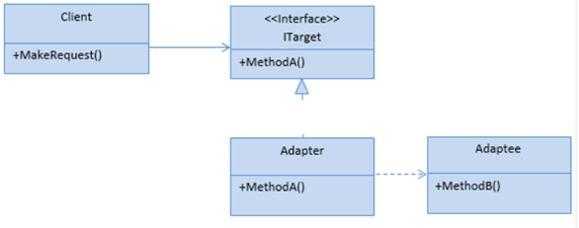

ITarget
This is an interface which has been used by the client to make a request.
Adapter
This is a class which implements the ITarget interface and inherits the Adaptee class. It is responsible for communication between Client and Adaptee. In our example, ResponsesStore is an Adaptee class.
Adaptee
This is a class which has the functionality required by the client. However, its interface is not compatible with the client.
Client
This is a class which interacts with a type that implements the ITarget interface.
PRACTICAL USE CASE

Imagine an online portal which displays the responses received for surveys from the survey recipients on its home page.
These responses are coming from a third-party vendor with which the portal has tied hands to get responses from.
The third-party vendor already has an inventory system in place which can give the list of responses for a particular survey as this third-party system is actually responsible for sending the survey to the recipients.
And there is no interface available to the online portal (Client) with which the portal can call the third-party vendor’s code to get the actual responses for a survey(s) which are being displayed on the portal home page.
Since we want to call the third-party vendor’s code which is incompatible with client (online portal) code we can apply “Adapter design pattern” here.
ITarget
A method which the online portal calls to get the list of responses and this request has been encapsulated in this interface.
Adaptee
The third-party vendor’s code which gives us the list of responses. Here ResponsesStore is the Adaptee class.
Adapter
The wrapper which would implement ITarget and would call third-party vendor’s code.
Client
The online portal code which gets the list of responses and then displays them.

- void Main() {
- var client = new Client(new Adaptar());
- var userResponses = client.GetResponsesRecieved();
- userResponses.ForEach(p => p.Dump());
- }
- public interface ITarget {
- List < string > GetResponses();
- }
- Public class Adaptar: ITarget {
- public List < string > GetResponses() {
- returnnew ResponsesStore().GetResponsesRecieved();
- }
- }
- Public class ResponsesStore {
- public List < string > GetResponsesRecieved() {
- var responses = new List < string > () {
- "This is a test response by user 1",
- "This is a test response by user 2",
- "This is a test response by user 3",
- "This is a test response by user 4"
- };
- return responses;
- }
- }
- Public class Client {
- private ITarget _target;
- public Client(ITarget target) {
- _target = target;
- }
- public List < string > GetResponsesRecieved() {
- return _target.GetResponses();
- }
- }

WHEN TO USE IT
This is really important to understand as the existence of design pattern doesn’t mean that we should use it just for the sake of using it; its actual use case is also important to understand. Thus, this pattern will be useful in the below-mentioned scenarios:
- Allow communication between the new and already existing system which are independent of each other.
- The Adapter design pattern is easy to implement and is quite common when legacy code is involved.

BENEFITS AND DRAWBACKS

It makes your code more structured and also supports the open/closed principle as you can add new adapters without disturbing the existing client code logic.
The complexity increases as you need to include a new interface or classes.

Behavioural Patterns

Strategy
This pattern falls under the category of behavioral pattern and as the name suggests, it allows clients to choose an algorithm from a set of algorithms at run time.
Strategy pattern defines a family of algorithms, encapsulates each one of them and makes them interchangeable at run time within that family.
Now let’s understand what each one of them actually means.
- Family of Algorithms: This means this pattern provides a set of algorithms using one of which at run time you can achieve the desired output.
- Encapsulate each one of the: This pattern allows you to place your algorithms in different classes (encapsulate them).
- Makes the algorithm interchangeable: The beauty with strategy pattern is that we can select at run time which algorithm we want to apply to our object and can also replace them with one another.
These are the three main points of Strategy pattern. I hope we are clear with the above- discussed points. So, let’s understand one real -world scenario where it can be really helpful to use.
Example
Suppose you want to go from one place to another and you want to see how much time it will take you to reach your destinations if you use different modes of transport. In this case you can implement the Strategy Pattern.
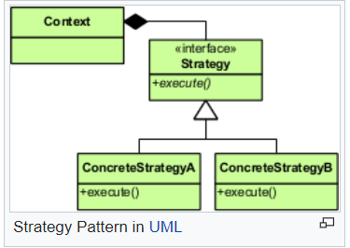
Clearly here we see the below things,
- An Interface called Strategy which has a method called execute () .
- Concrete Strategy classes A and B which implement that Interface.
- Lastly one Context class using which we can use different concrete strategies at run time.

- Interface
- public interface IStrategy {
- string GetTravelTime(string source, string destination);
- }
- Concrete classes
- public class CarStrategy: IStrategy {
- public string GetTravelTime(string source, string destination) {
- return "It takes 40 minutes to reach from " + source + " to " + destination + " using Car.";
- }
- }
- public class BikeStrategy: IStrategy {
- public string GetTravelTime(string source, string destination) {
- return "It takes 25 minutes to reach from " + source + " to " + destination + " using Bike.";
- }
- }
- public class BusStrategy: IStrategy {
- public string GetTravelTime(string source, string destination) {
- return "It takes 60 minutes to reach from " + source + " to " + destination + " using Bus.";
- }
- }

- Context class
- public class TravelStrategy {
- private IStrategy _strategy;
- public TravelStrategy(IStrategy chosenStrategy) {
- _strategy = chosenStrategy;
- }
- public void GetTravelTime(string source, string destination) {
- var result = _strategy.GetTravelTime(source, destination);
- Console.WriteLine(result);
- }
- }

- Main program
- void Main() {
- Console.WriteLine("Hello!, Please select the mode of transport to get the travel time between source and destination: \nCar \nBike \nBus");
- var userStrategy = Console.ReadLine().ToLower();
- Console.WriteLine("\nUser has selected *" + userStrategy + "* as mode of transport\n");
- Console.WriteLine("\n*****************************************************************************************************\n");
- switch (userStrategy) {
- case "car":
- new TravelStrategy(new CarStrategy()).GetTravelTime("Point A", "Point B");
- break;
- case "bike":
- new TravelStrategy(new BikeStrategy()).GetTravelTime("Point A", "Point B");
- break;
- case "bus":
- new TravelStrategy(new BusStrategy()).GetTravelTime("Point A", "Point B");
- break;
- default:
- Console.WriteLine("You have chosen an invalid mode of transport.");
- break;
- }
- }

When to use this pattern?
Use this pattern when there are multiple similar classes that only differ in terms of how they execute the behavior.
Some common use cases
- Giving different permissions depending on role and department.
- Giving discount depending on different conditions/coupons/happy hours etc.
- It can be used in games, considering the surrounding conditions player can either swim (In water), trek (on mountain), jump (hurdles) or walk (on road).

Observer Pattern
This pattern falls under the category of behavioral pattern. As the name suggests, it is based on the principle where one object observes another object.
So, in simple words, this pattern defines a one-to-many relationship between subject and observer objects so that if the subject changes its state, then all of the dependent observer objects will be notified of the change.
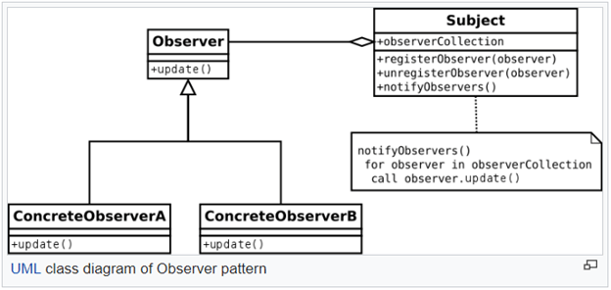
Consider a technical author like we have in C# Corner, who writes blogs, articles etc. So, if someone likes reading articles from a specific author, one can follow/subscribe the author for future articles. This is a real-life scenario of the Observer pattern.
In this case, all the subscribers who want to subscribe to the author are Observer Objects and the author is a Subject.
Author interface being subject as its name
- public interface ISubject {
- void registerObserver(Observer observer);
- void unregisterObserver(Observer observer);
- void notifyObservers();
- }

Whenever the subject changes it state need to be updated
- public class Subject: ISubject {
- private List < Observer > Observers = new List < Observer > ();
- private int articlesCount = 1;
- public int Articles {
- get {
- return articlesCount;
- }
- set {
- if (value > articlesCount) {
- articlesCount++;
- notifyObservers();
- }
- }
- }
- public void registerObserver(Observer observer) {
- Observers.Add(observer);
- }
- public void unregisterObserver(Observer observer) {
- Observers.Remove(observer);
- }
- public void notifyObservers() {
- foreach(var observer in Observers) {
- observer.Update();
- }
- }
- }

This is the interface which will be implemented by all the Observer objects. As per our example, all the subscribers/followers for the author will be the Observer objects.
- public interface IObserver {
- void Update();
- }

This is the Observer class which can be used to create different observers.
- public class Observer: IObserver {
- public string ObserverName;
- public Observer(string name) {
- ObserverName = name;
- }
- public void Update() {
- //Observer can update his system accordingly
- Console.WriteLine("Hello " + ObserverName + ", a new article has been published by the author.");
- }
- }

- void Main() {
- var subject = new Subject();
- var observerA = new Observer("Observer A");
- var observerB = new Observer("Observer B");
- var observerC = new Observer("Observer C");
- Console.WriteLine("Intially suppose Subject has already written total " + subject.Articles + " article");
- Console.WriteLine("\n*******************************************************************************\n");
- Console.WriteLine("Registering observers A and B for future articles...............");
- subject.registerObserver(observerA);
- subject.registerObserver(observerB);
- Console.WriteLine("New article published by Subject,so now observers A and B will be notified....\n");
- subject.Articles++;
- Console.WriteLine("---------------------------------------------------------------------------\n");
- Console.WriteLine("Registering observer C for future articles and unregistering observer B from the future articles...............");
- subject.registerObserver(observerC);
- subject.unregisterObserver(observerB);
- Console.WriteLine("New article published by Subject,so now observers A and C will be notified....\n");
- subject.Articles++;
- Console.WriteLine("\n*******************************************************************************\n");
- Console.WriteLine("Finally Subject has written total " + subject.Articles + " article \n");
- }

Output
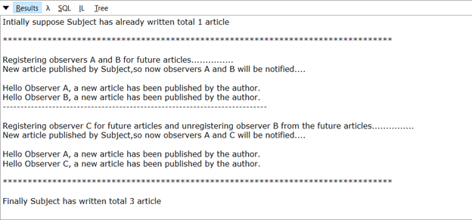
When should we use this
We should use it when multiple objects are dependent on the state of one object.
Some common Use Cases
- Following someone on Instagram/Twitter and other such platforms.
- App users gets notified for the updates.
- Email Subscriptions and many more.

